 LONGSPRING WOODS
PLEDGE FORM FOR FINANCIAL DONATIONS
(any funds donated will be earmarked for the sole purpose of the Longspring Woods project)

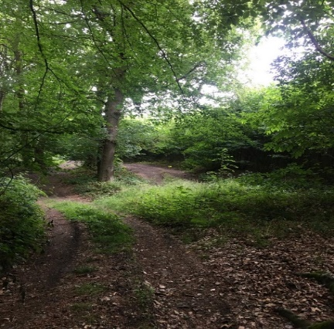
Longspring Woods is made up of two parcels of ancient woodland which has persisted since 1600 in England. They are both located within the Green Belt and Area of Outstanding Natural Beauty.

Sevenoaks Town Council has registered Longspring Woods as an Asset of Community Value (ACV). One of the two woods is currently up for sale and due to the ACV registration conveyance is halted for 6 months to enable the Town Council to consider whether it wishes to purchase the woods for the community. The vendor is not obliged to sell to the Town Council.

The overall project including purchase and immediate improvements relating to access and information will cost approximately £200,000. The Town Council is keen to bring the ancient woods into public ownership, complimenting the nearby common, and protecting for future generations. There is a limited amount of time to acquire funds, e.g., external grants. The Town Council has immediate access to £100,000 from capital receipts from land sold many years ago and this can be utilised. Sevenoaks Town Council is also seeking public support for this either in financial donations or In Kind. We are delighted that Warners Solicitors have offered to waive conveyance charges.

You can Pledge your support for this community project by completing the form below of contacting Sevenoaks Town Council and we will contact you asap. We need Pledges by 23rd February 2024 please for the Town Council to make a decision on 26th February 2024.

Name

Email Address

Telephone Number

I would like to Pledge | £
I could contribute the following In Kind

